Momentum
Linear Momentum (p) is a measure of the quantity of motion of a moving body.
- Equation: p = m × v
- SI Unit: kilogram meter per second (kg m s⁻¹ or N s).
- Key Fact: Momentum is a vector quantity. It has both magnitude and direction.
Conservation of momentum: total momentum before = total momentum after , provided no external resultant force acts on the system(closed isolated system).
- "System": The group of objects you are considering.
- "External resultant force": Forces from outside the system (e.g., friction, gravity if objects are large). Internal forces (objects pushing on each other) do not change the total momentum.
- This principle applies to all collisions, explosions, and Jet propulsion / rocket motion.

Force and Momentum: The Fundamental Connection
Newton's Second Law says:
“The net force acting on a body is equal to the rate of change of its linear momentum.”
Therefore:
$F= \frac{Δp}{Δt}$​
Newton's Third Law says:
“When two bodies interact, the force on body A from body B is equal in magnitude but opposite in direction to the force on body B from body A”
$$F_{A on B}=−F_{B on A}$$

How This Leads to Momentum Conservation
For two interacting bodies A and B:
$$F_{A on B}=−F_{B on A}$$
Apply Newton's Second Law to each:
  - Force on B = rate of change of B's momentum: $F_{A on B}=\frac{Δp_{B}}{Δt}$
  - Force on A = rate of change of A's momentum: $F_{B on A}=\frac{Δp_{A}}{Δt}$
Put these together:
$$\frac{Δp_{B}}{Δt}=−\frac{Δp_{A}}{Δt}$$
Multiply by time (same Δt for both):
$$Δp_{B}=−Δp_{A}$$
​$Δp_{A}+Δp_{B}=0$
This means: The total change in momentum is zero → Total momentum is conserved.

What This Means for Collisions
During any collision:
- the forces on the two bodies (or on A and B) are equal and opposite (Newton 3rd)
- force equal/is proportional to rate of change of momentum (Newton 2nd)
- The time is the same for both forces hence change in momentum is the same
Momentum is always conserved (in a closed system of course) so when an object collides with the wall or with the ground even though the momentum of object itself reduce and the ground/wall might not have noticeable motion (there actually is but its too small to notice) but the momentum is transferred to the ground/wall or even earth.
the reason the motion is small is because relatively the mass of earth is too big meaning the velocity is too small (negligible)

One-Dimensional Momentum Problems
For problems in one line (e.g., along a straight track), we use a sign convention.
General Conservation Equation:
$$m_{1}u_{1}+m_{2}u_{2}=m_{1}v_{1}+m_{2}v_{2}$$
(where $u$ = initial velocity, $v$ = final velocity)
Rule: ALWAYS define your positive direction before starting a calculation.
Type 1: Collisions
Worked Example 1 (Inelastic Collision - Objects Stick Together)
A trolley of mass $2.0kg$ moving at $3.5{ms}^{−1}$ collides with a stationary trolley of mass $1.5kg$. They stick together and move off. Calculate their common velocity.
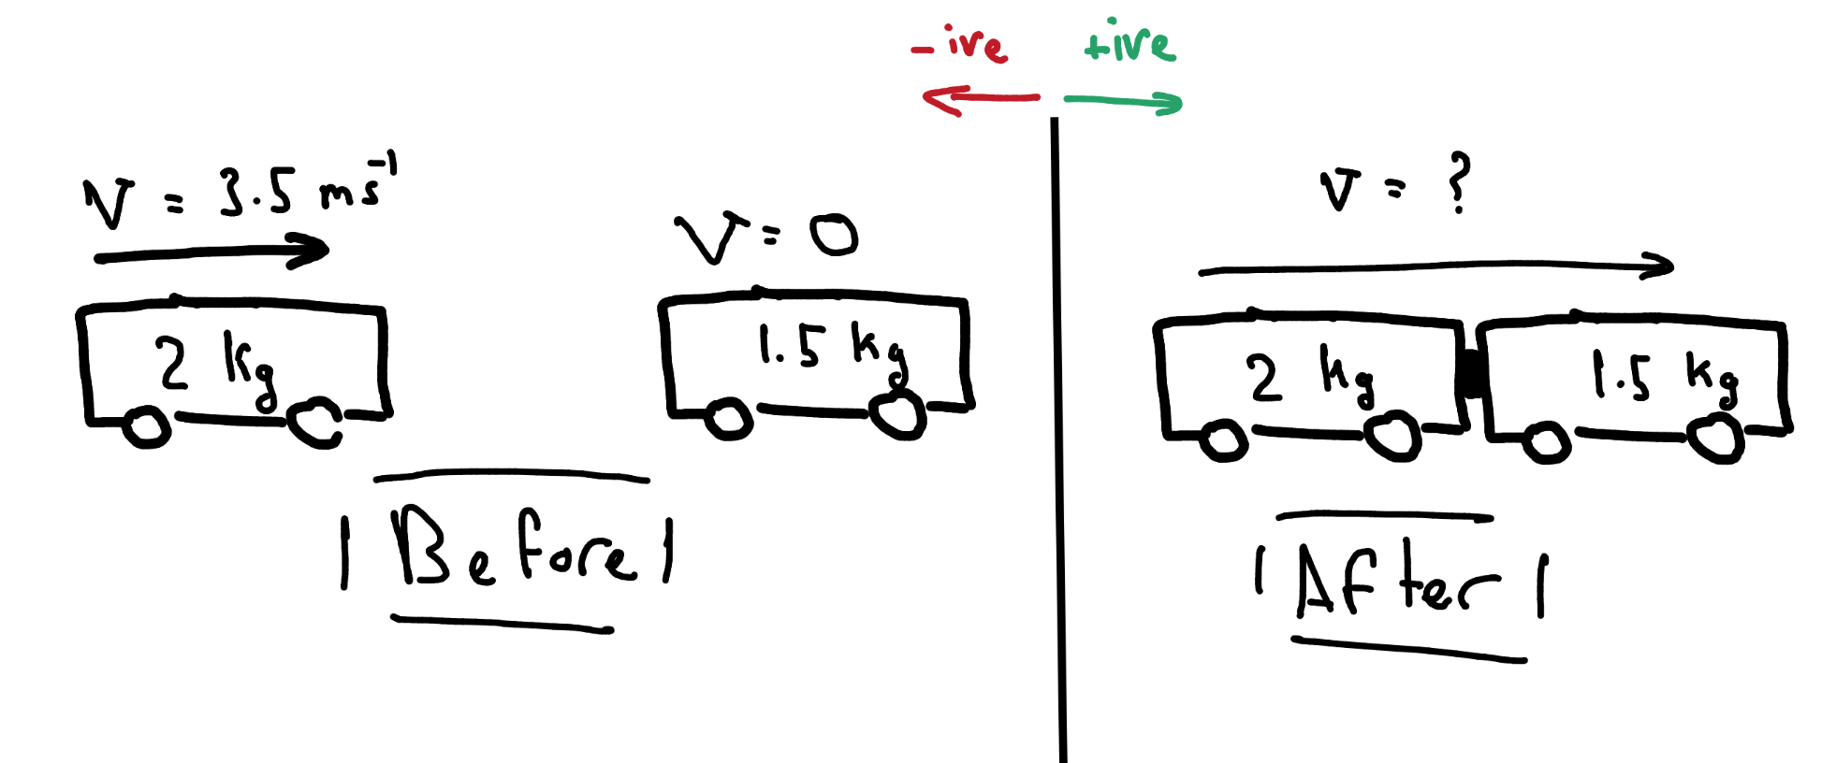
Step-by-Step Solution:
Equation Setup:
Total momentum before = Total momentum after
$$m_{1}u_{1}+m_{2}u_{2}=(m_{1}+m_{2})v$$
Substitution & Solve:
$$(2.0×3.5)+(1.5×0)=(3.5)×v$$
$$7.0+0=3.5v$$
$$v=\frac{7.0}{3.5}=2.0{ms}^{−1}$$
Answer with Direction:
$v=2.0{ms}^{−1}$ in the original direction of motion (positive).
Type 2: Explosions
Objects are initially together and stationary. They separate due to an internal force (e.g., a spring). Total momentum before an explosion is zero.
Equation from Conservation $0=m_{1}{\vec{v}}_{1}+m_{2}{\vec{v}}_{2}$
Therefore: $m_{1}{\vec{v}}_{1}=−m_{2}{\vec{v}}_{2}$
(The momenta are equal in magnitude but opposite in direction).
Worked Example 2 (Explosion)
A stationary firework of mass $0.40kg$ explodes into two pieces. Piece A ($0.15kg$) flies off to the right at $6.0{ms}^{−1}$. Calculate the velocity of piece B ($0.25kg$).
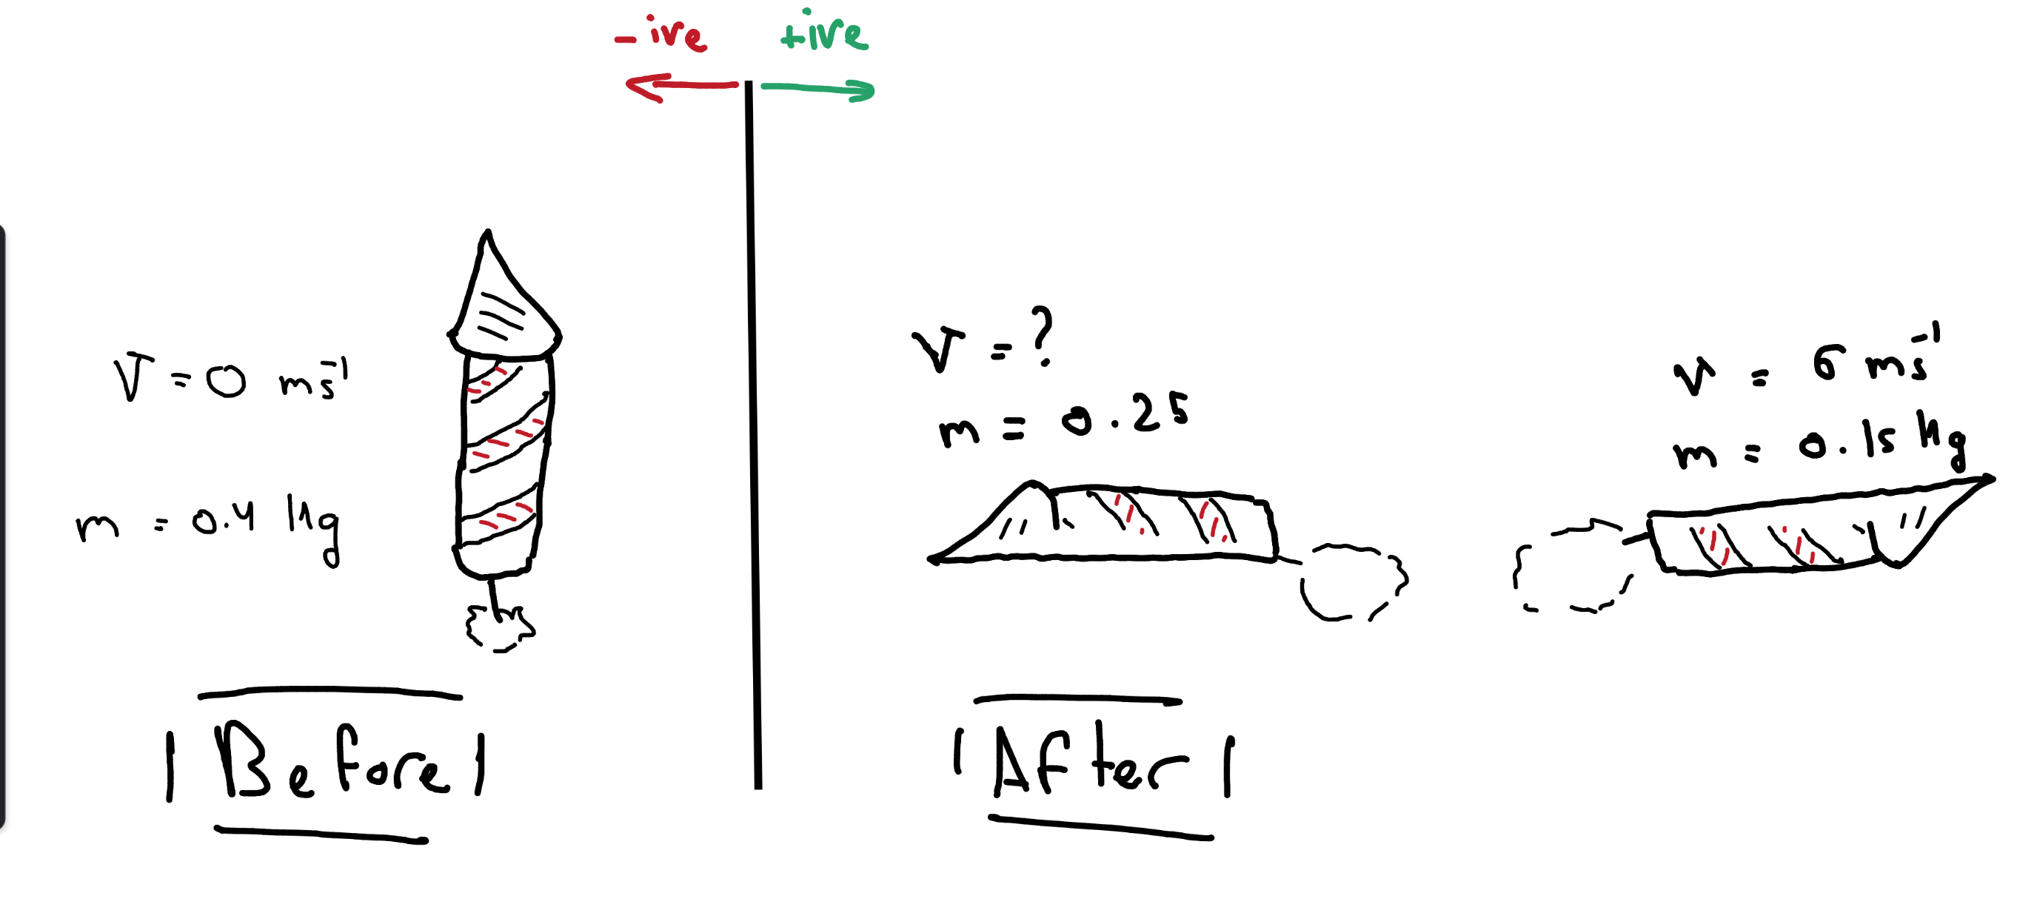

Equation:
$$0=m_{A}v_{A}+m_{B}v_{B}$$
Substitute:
$$0=(0.15×6.0)+(0.25×v_{B})$$
$$0=0.9+0.25v_{B}$$
​$v_{B}=\frac{−0.9}{0.25}=−3.6{ms}^{−1}$
Answer: Velocity of piece B is $3.6{ms}^{−1}$3.6 m s−1 to the left.

Elastic vs. Inelastic Collisions
Collisions are classified by what happens to kinetic energy ($E_{k}$​).
- Elastic Collision: Total kinetic energy is conserved. (KE before = KE after)
- Inelastic Collision: Total kinetic energy is NOT conserved.

Definition Table
Feature | Elastic Collision | Inelastic Collision | Perfectly Inelastic
Kinetic Energy | Conserved  $$E_{k,before}=E_{k,after}$$ | Not conserved  $$E_{k,before}>E_{k,after}$$ | Maximum loss  Objects stick together
Momentum | Conserved | Conserved | Conserved
Energy Transformation | None (ideal) | → Heat, sound, deformation | → Heat, sound, deformation
Relative Speed Rule | Speed of separation = Speed of approach | Speed of separation < Speed of approach | Minimum speed of separation
Examples | Billiard balls, gas molecules (approx.) | Car crashes, putty hitting wall | Two objects sticking together

The Kinetic Energy Rule
Definition:
- Kinetic Energy before = $E_{k,before}=\frac{1}{2}m_{1}u_{1}^{2}+\frac{1}{2}m_{2}u_{2}^{2}$
- Kinetic Energy after = $E_{k,after}=\frac{1}{2}m_{1}v_{1}^{2}+\frac{1}{2}m_{2}v_{2}^{2}$
Rule:
$$E_{k,before}=E_{k,after}$$
$$\frac{1}{2}m_{1}u_{1}^{2}+\frac{1}{2}m_{2}u_{2}^{2}=\frac{1}{2}m_{1}v_{1}^{2}+\frac{1}{2}m_{2}v_{2}^{2}$$

The Relative Speed Rule
Definition:
Absolute value (“$|$$|$”) was used to make sure the values for relative speed of approach/ separation are always positive
- Speed of approach = $|u_{1}−u_{2}|$ (before collision)
- Speed of separation = $|v_{2}−v_{1}|$ (after collision)
Rule:
$$|v_{2}−v_{1}|=|u_{1}−u_{2}|$$
where $u_{1},u_{2}$​ are initial velocities and $v_{1},v_{2}$​ are final velocities.

Two-Dimensional Momentum
In 2D, momentum is conserved independently in perpendicular directions (e.g., $x$ and $y$).
Method:
- Resolve all velocities into components.
- Apply conservation of momentum separately for the $x$x-components and the $y$y-components.
- $∑initial p_{x}=∑final p_{x}$
- $∑initial p_{y}=∑final p_{y}$​
- Combine the final $x$x and $y$y momentum components to find resultant velocities.
Worked Example 3 (Oblique Collision with Stationary Object)
A ball A (mass $m$) moving at $5.0 {m s}^{−1}$ East collides with a stationary identical ball B. After collision, ball A moves at $3.0 {m s}^{−1}$at ${30}^{∘}$ North of East. Find the velocity of ball B.
(Take East as postive $x$, North as positive $y$.)
initial Momentum:
$$p_{x}(initial):m×5.0+m×0=5.0m$$
$$p_{y}(initial):0+0=0$$
Resolve Final Velocities:
$$A: v_{Ax}=3.0\cos{{30}^{∘}}≈2.60{m s}^{−1} ,v_{Ay}=3.0\sin{{30}^{∘}=1.50{m s}^{−1}}$$
$B: v_{Bx}=?,v_{By}=?(Let velocity be v_{B}​ at angle θ)$
Apply Conservation:
$$x-direction: 5.0m=m(2.60)+m(v_{Bx})⇒v_{Bx}=5.0−2.60=2.40{m s}^{−1}$$
$$y-direction: 0=m(1.50)+m(v_{By})⇒v_{By}=−1.50{m s}^{−1}$$
Find Magnitude & Direction of ${\vec{v}}_{B}$​:
Magnitude: 𝑣𝐵=(2.40)2+(−1.50)2=5.76+2.25=8.01≈2.83m s−1
Direction: $θ={tan⁡}^{−1}\left(\frac{∣1.50∣}{2.40}\right)≈{32}^{∘}$ South of East (since $v_{By}$is negative)

Force on Fluids: Mass Flow Rate

Mass Flow Rate
Mass flow rate ($ṁ$) is the mass of fluid passing a point per unit time.
$$ṁ=\frac{Δm}{Δt}or ṁ=ρAv$$
Where:
- $ṁ$ = mass flow rate (kg s⁻¹)
- $ρ$ = density of fluid (kg m⁻³)
- $A$ = cross-sectional area (m²)
- $v$ = flow velocity (m s⁻¹)

Force from Fluid Flow
$$F=ρAv^{2}​$$
Where:
Note: this formula can only be used When fluid accelerates from rest OR decelerates to rest

- $F$ = Force on fluid (N)
- $ρ$ = Density of fluid (kg/m³)
- $A$ = Cross-sectional area (m²)
- $v$ = Flow speed (m/s)

Worked Example 4: Water Jet on Wall
Water of density $ρ=1000kg m⁻³$ emerges from a hose of area $A=4.0 ×{10}^{−4}{ m}^{2}$ at $v=15m s⁻¹$ and hits a wall perpendicularly. Calculate the force on the wall.
Apply the formula
$$F=ρAv^{2}$$
Substitute values
Interpretation
- Force on water by wall = $−90N$ (opposite to flow)
- Force on wall by water = $+90N$ (in direction of initial flow)

$$F=1000×(4.0×{10}^{−4})×(15)^{2}$$
Calculate
$$F=1000×4.0×{10}^{−4}×225$$
$$F=90N$$

